NYC Property sales data description

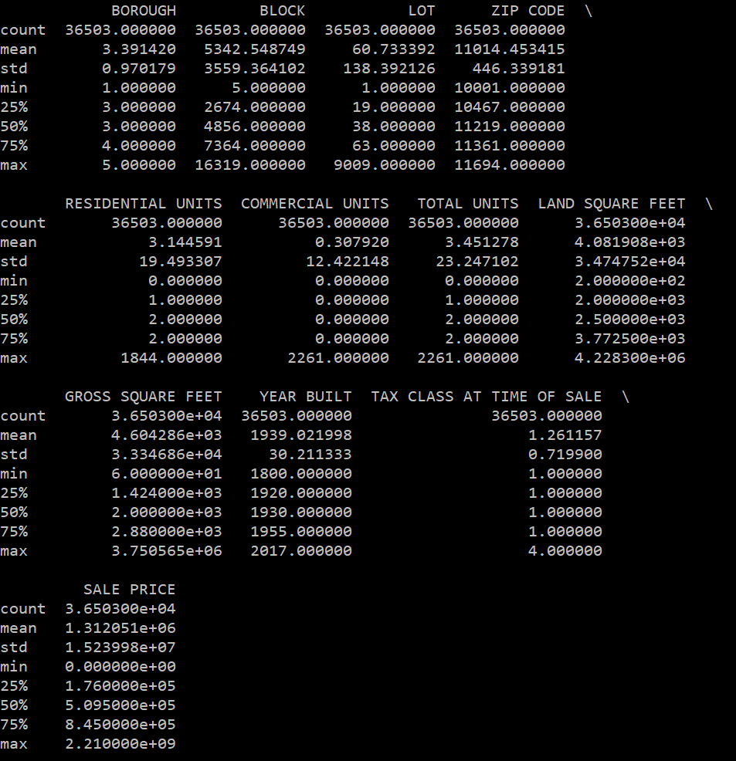

**OUTLIER TREATMENT**

COLUMN or VARIABLE: ‘SALE PRICE’ - TARGET VARIABLE – (+-)2SD

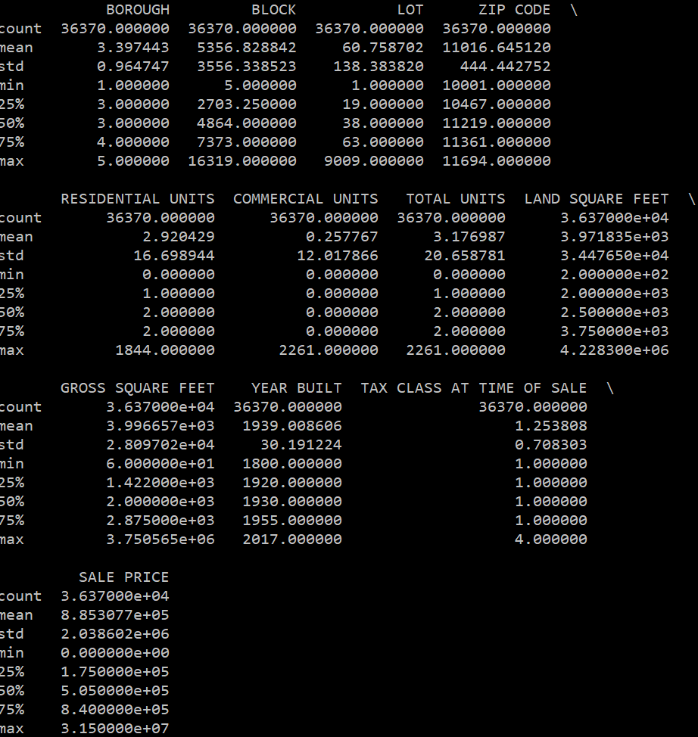

Building Age – (+-2SD)

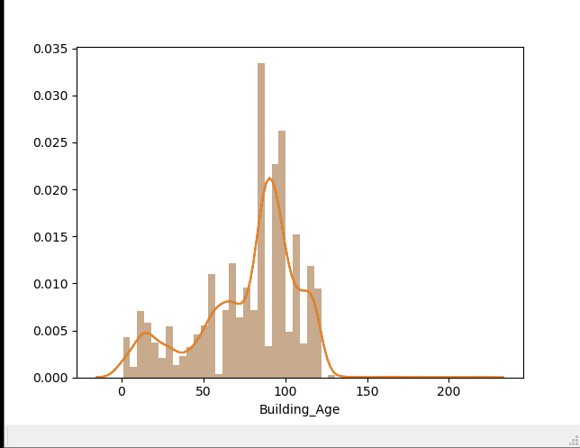

Data_v2 Description

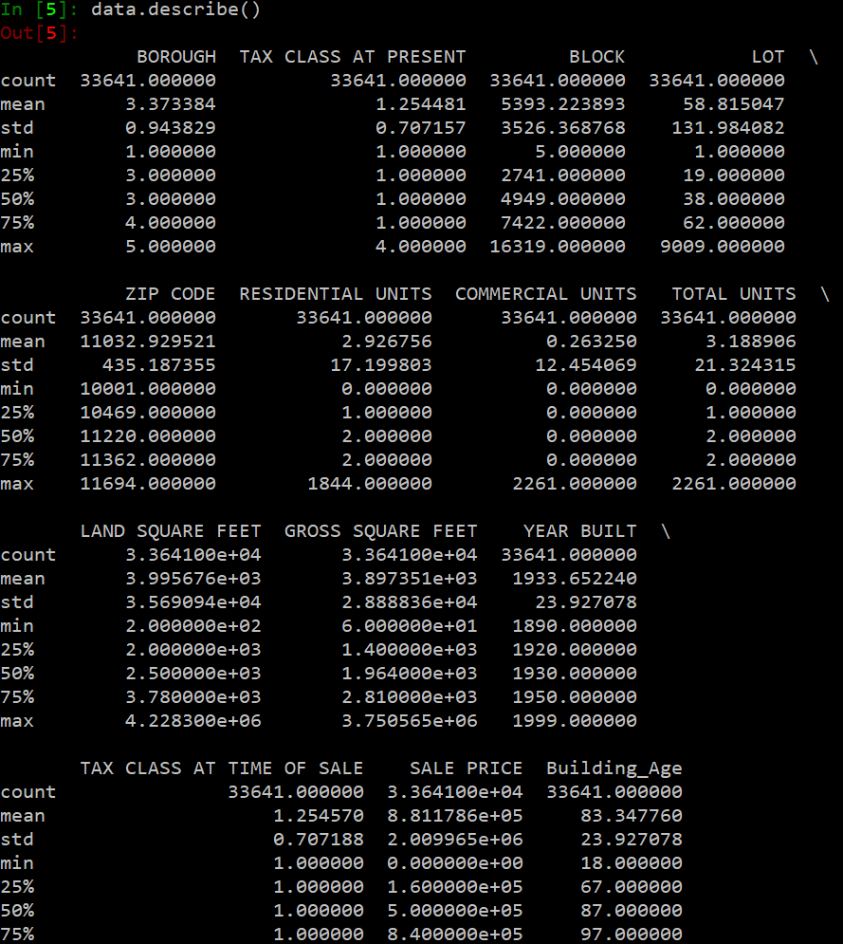

Data Visualization using Tableau.

Neighborhood Vs Avg(Sale Price)

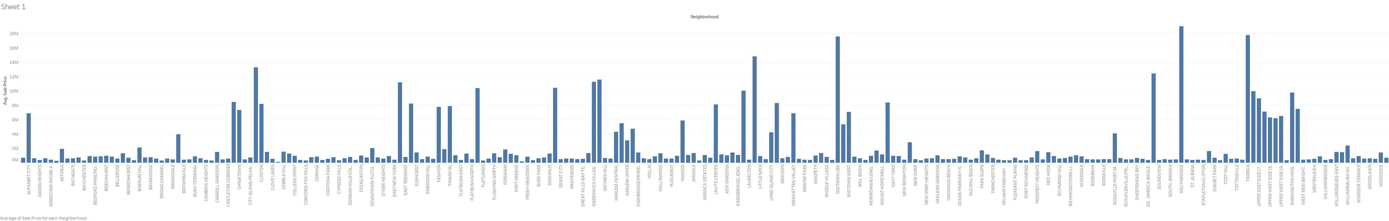

Building Class at Time of Sale Vs Avg(Sale Price)

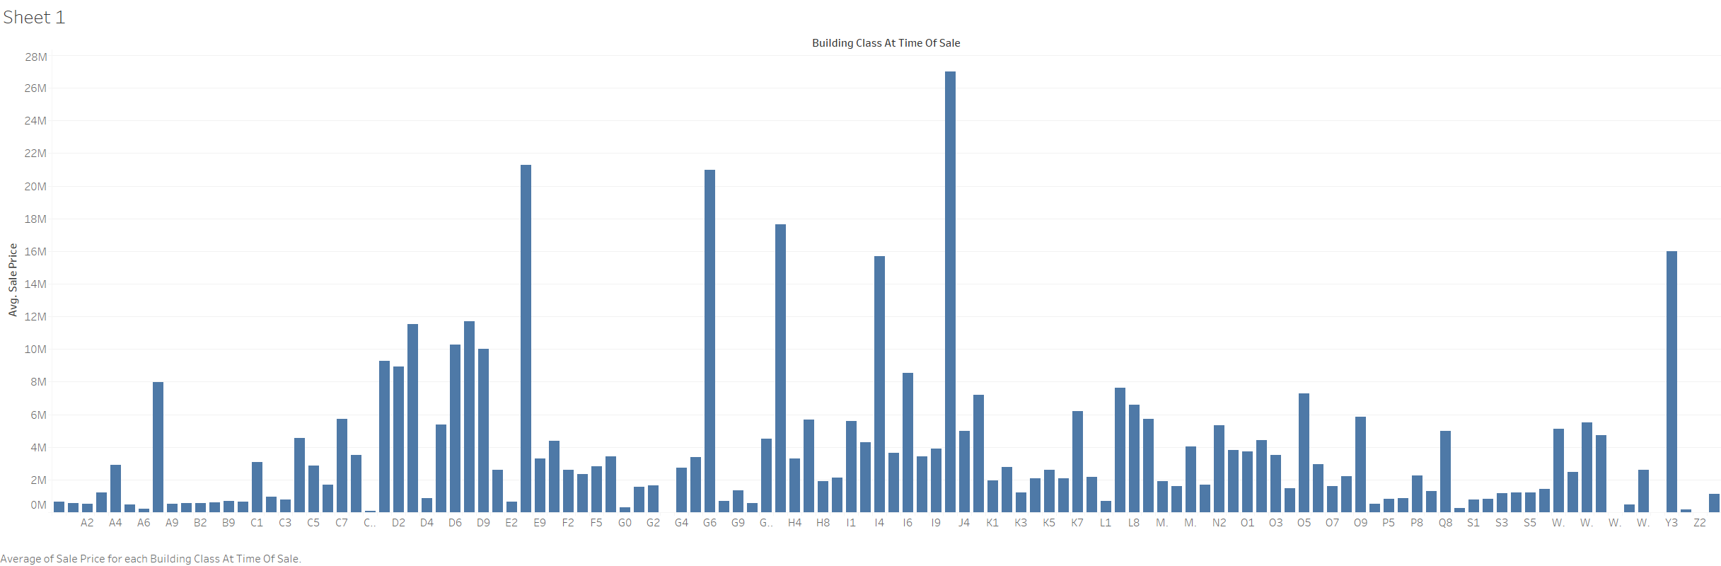

Sale Month/Year Vs Avg(Sale Price)

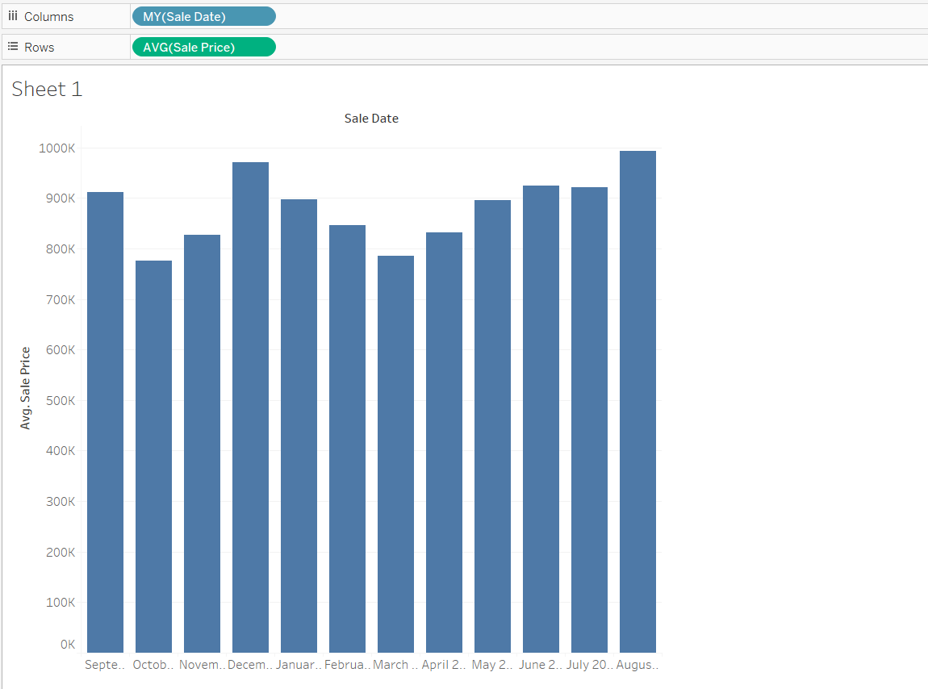

Building Age(Bin) Vs Avg(Sale Price)

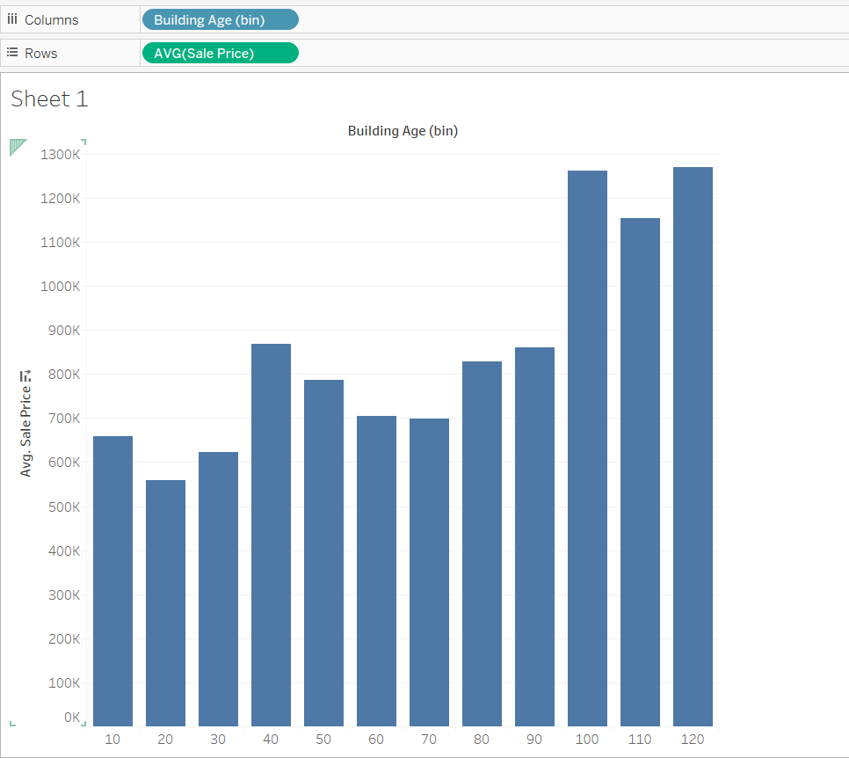

ZIP CODE (Bin) Vs Avg(Sale Price)

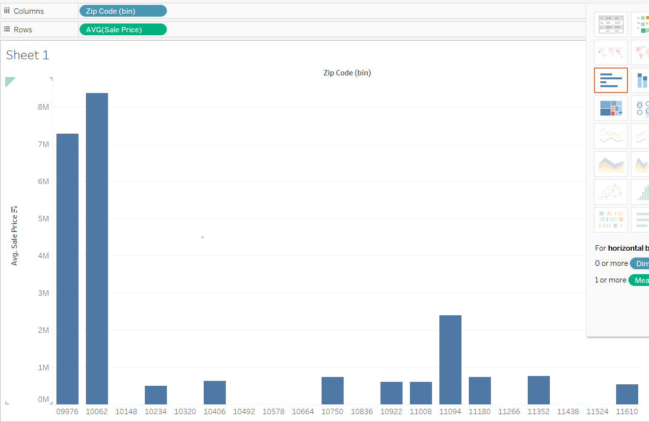

Borough Vs Avg(Sale Price)

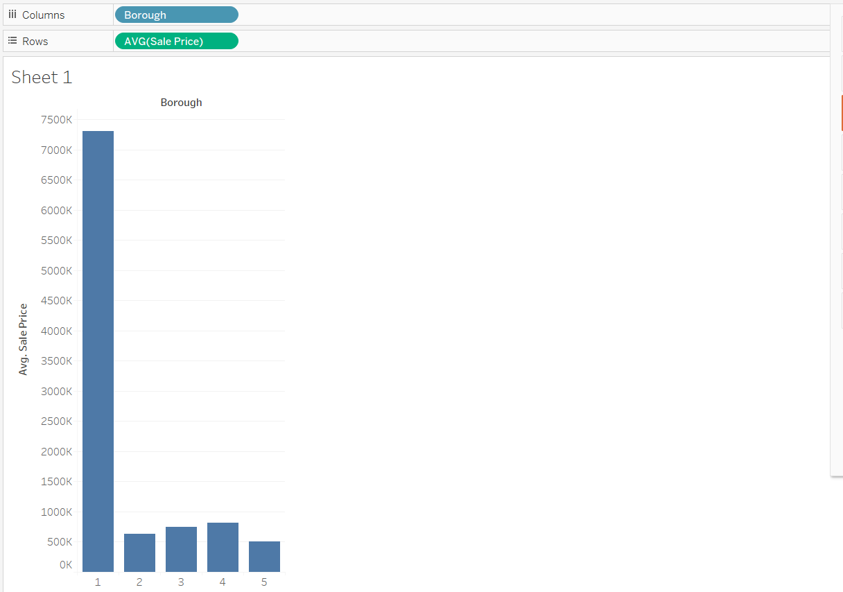

Tax Class At time of Sale Vs Avg(Sale Price)

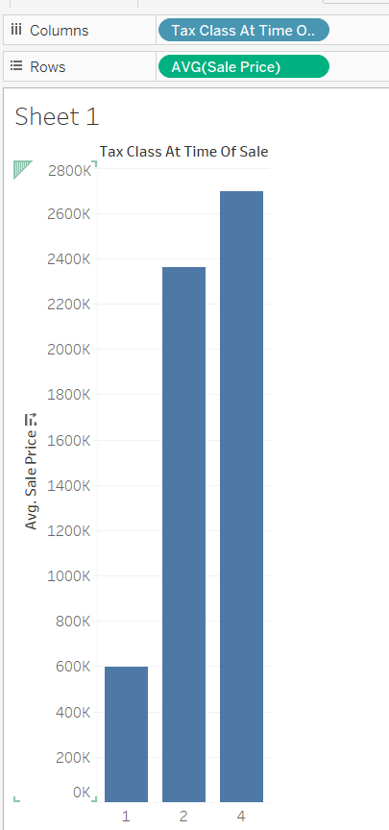

Building Class Category Vs Avg(Sale Price)

